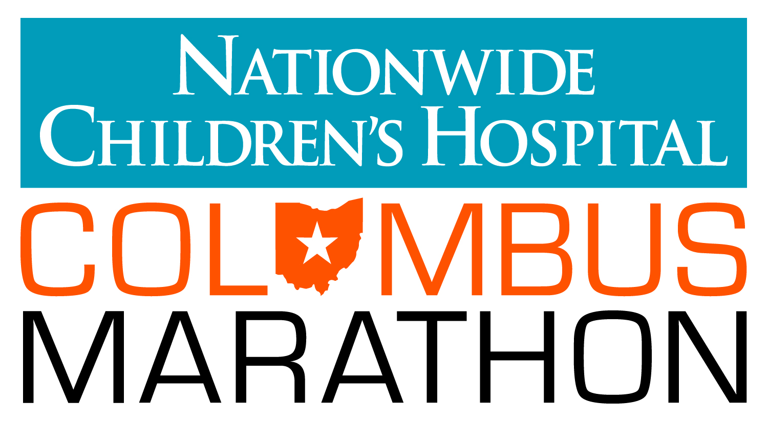

FOR IMMEDIATE RELEASE FOR MORE INFORMATION:
Sept. 30, 2015 Sarah Irvin Clark, Irvin PR, 614.296.4057 (cell)

NATIONWIDE CHILDREN’S HOSPITAL COLUMBUS MARATHON
TO FEATURE RECIPIENTS OF SPIRIT AWARD
Eighth Annual Award highlights individuals with bravery and perseverance
(COLUMBUS, OH) — The 36th Anniversary Nationwide Children’s Hospital Columbus Marathon & ½ Marathon, to be held on Sunday, Oct. 18, will spotlight 10 runners and walkers out of a field of 19,000 who have overcome enormous obstacles to train for and participate in the marathon or ½ marathon.

The winners will receive a special invitation to the Nationwide Children’s Hospital Columbus Marathon VIP event the Friday of Race Weekend, and will be recognized at the start line for their accomplishments.

###

2015 Spirit Award Winners

Cristina Saint-Blancard, Plantation, FL
“There are no obstacles if you’re willing to work hard to overcome them” is Cristina’s motto. While volunteering and working on her graduate research in the NICU at Nationwide Children’s Hospital, she acquired an infection that lodged through her ears and quickly spread to her brain, leaving her basically deaf and almost killing her. Through courage and positive attitude and living life as a survivor not a victim, Cristina has lost over 170 pounds and is excited to complete her FIRST half marathon back in Columbus and in benefit of the hospital where “it all started.”

Sonya Rae Evans, West Union, OH
In January 2013, Sonya learned she had stage 3, non-small cell lung cancer. Sixteen months after completing her radiation and chemotherapy treatments, Sonya ran in the 2014 Flying Pig Half Marathon. Sonya’s tumor has stopped growing but it is inoperable. She attributes her determination and strength to God and God’s healing powers. According to her nomination, “Sonya sees the world with such gratitude and grace and is an inspiration to all who know her.”
Andrea and Alyson Hoffman, Marion, OH
Andrea and Alyson Hoffman are twins with cystic fibrosis and patients at Nationwide Children’s Hospital. The twins will run in the half marathon to prove how important exercise is to those living with cystic fibrosis. Despite enduring daily medications and breathing treatments, Andrea and Alyson have seen improvements in their health by taking one step at time. Team HEAL (Hoffmans Exercising Adding Life) is raising money for the estimated one million children who will walk through Nationwide Children’s Hospital this year.

Andrew Leatherman, Dublin, OH
At age 36, Andy Leatherman will participate in his second 1/2 marathon on Oct. 18. Andy was born with Cystic Fibrosis and has been a patient at Nationwide Children’s Hospital since birth. Andy was not expected to live past the age of 18, let alone be one of very few CF patients living into their mid 30's and running. After losing his brother Peter at age 26 from Cystic Fibrosis and developing Type II Diabetes from disease progression, Andy was inspired by his girlfriend to begin running. Andy embodies a “no excuses” mantra that inspires others. According to one of the four Spirit Award nominations submitted on Andy’s behalf, “If he can overcome work/health/life obstacles to still conquer his goals, while dealing with Cystic Fibrosis, then I certainly can as well!”

Shanel Mees, Cincinnati, OH
Shanel is not letting a diagnosis of Psoriatic Arthritis prevent her from running her first full marathon this year. Despite joint pain, stiffness and swelling caused by the autoimmune condition, Shanel has pushed herself to increase her running pace of 8:15-8:30 mile (before she was diagnosed) to 7:20-7:30 mile. Shanel will run to raise money for the National Psoriasis Foundation and prove that determination is stronger than any condition.
Rachel Schade, Delaware, OH
Rachel is participating her first half marathon, shortly over a year after enduring tragic loss. After losing her parents in a motorcycle accident, Rachel assumed responsibility of her youngest sibling who was entering his senior year of high school. Rachel found a job with benefits for her and her brother and moved to a bigger apartment so he could have his own room. Her brother entered his first year of college this year. Rachel is a true testament of strength and spirit.
Jenn Smiechowski, Westerville, OH

Jenn began running after the birth of her son and participated in several half marathons and the Columbus Marathon in 2013. The birth of her daughter prevented her from participating in the 2014 Columbus Marathon but she resumed training, as soon she was able. This spring, while on a training run, her heart developed a life-threatening tachycardia. She recovered but received the diagnosis of ARVD (Arrhythmogenic Right Ventricular Dysplasia) which meant that she could no longer participate in distance running or competitive sports. Jenn instead will walk the 1/2 marathon this year to support her friends who are running and advocate heart health awareness for runners.

Terence Tobias, Columbus, OH
Terence is a member of Columbus Sole, a running group with the male residents of the downtown YMCA. The mission of the team is to empower the residents through running by providing the opportunity to commit to a goal, experience accomplishment, build trust in others and connect to their community. Terence, along with the other members of the team, has faced many obstacles in life. Yet, despite setbacks, these men come out to practice every Monday and Thursday, work hard and bond with individuals they may have never gotten a chance to meet otherwise. Terence is a leader within our group. He promotes camaraderie, team unity, hard work and dedication to accomplishing goals. Terence set the goal to train and complete a marathon by the end of the season. With guidance from YMCA volunteers, Terence was able to make a training plan, incorporate healthy eating habits and set realistic pace goals. He recently ran and
completed the Dublin Emerald City Half Marathon run in 2:10, which is a significant accomplishment for someone who could barely run a mile when Columbus Sole first started over two years ago. His dedication to this goal has been nothing short of inspiring and motivational for the rest of the team.

Justin Thomas, Roaming Shores, OH
Justin is competing in his first Columbus half marathon this year with a goal of beating his personal record of 1:16:30. Justin’s journey began in 2004 when he was in a tragic car accident when he dislocated his hip, suffered spine injuries and severe lacerations, resulting in eight surgeries in 3 days. His journey back to running was long and difficult and included 15 more surgeries and severe pain. Still, Justin with encouragement from his wife and best friend, Justin went on to qualify and participate in the Boston Marathon. According to Justin, “It’s not the overall time that makes one special, not the speed, or even the endurance. It’s not the glory of victory or even the agony of defeat. At the end of the day, YOU and only you make yourself special. There is always a finish line in the distance. You may not always see the finish line, but keep pushing, and I promise, your legs and heart will find it.”

###

About The Nationwide Children’s Hospital Columbus Marathon & ½ Marathon
The Nationwide Children’s Hospital Columbus Marathon & ½ Marathon will be held on Sunday, Oct. 18, 2015 and will feature up to 19,000 athletes. The Marathon, now in its 36th year, is the largest marathon in Ohio and the 16th largest in the United States. The ½ Marathon is celebrating its 10th anniversary in 2015 and is the largest ½ Marathon in Columbus. More than $3 million has been raised for Nationwide Children's Hospital since it became the title beneficiary of the event in 2012. For more information, visit www.columbusmarathon.com.

About Nationwide Children’s Hospital
Nationwide Children’s Hospital is honored to serve as the title beneficiary of the Nationwide Children’s’ Hospital Columbus Marathon & 1/2 Marathon. “Patient Champions” will represent 24 of the 26.2 miles on this year’s course. The other two miles along the Marathon route will be deemed the “Encore Mile” (Patient Champions from 2012 and 2013) and “Angel Mile” (dedicated to the angels of Nationwide Children’s who have passed on). The Patient Champions and their families will cheer on participants and serve as a visual reminder of how the marathon is helping ill and injured children. Children’s Champions are participants, who chose to run, walk or cheer for the marathon or ½ marathon while fundraising for Nationwide Children’s Hospital. As a Children’s Champion, these hundreds of individuals are reaching beyond personal training goals to support another mission. To cure, to mend, and comfort each child that walks through the doors of Nationwide Children’s. Their fundraising efforts help provide every child with the highest quality of care, regardless of the child’s diagnosis or the family’s ability to pay. The marathon and ½ marathon may be full, but there’s still time to become a Children’s Champion. To learn more about the Patient Champions or fundraising efforts visit nationwidechildrens.org/marathon.

# # #

