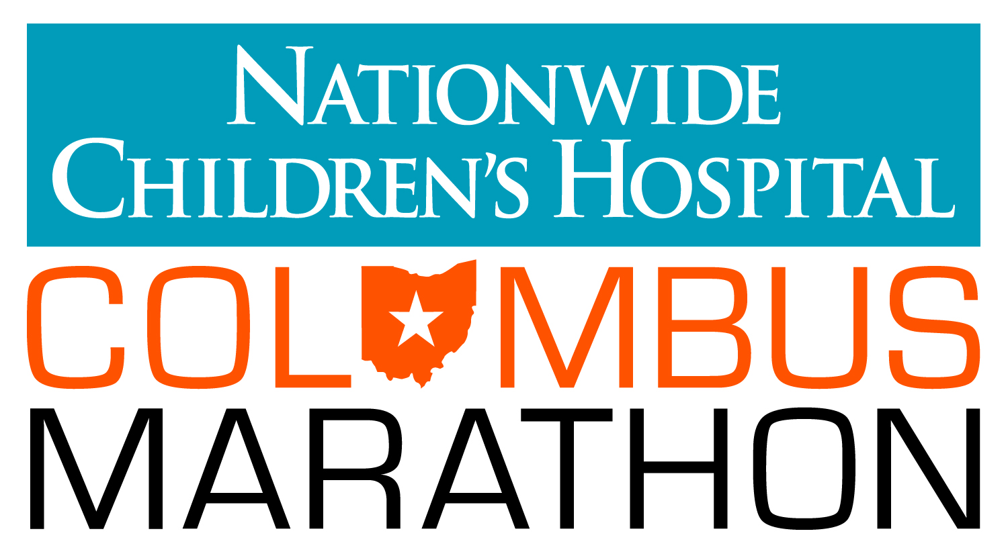

MEDIA ADVISORY *** MEDIA ADVISORY *** MEDIA ADVISORY
FOR IMMEDIATE RELEASE

Marathon Events and Media Opportunities for Race Week:
Race Day set up already taking place at Start/Finish area
___________________________________________________________________________

WHAT: The 36th Nationwide Children’s Hospital Columbus Marathon & ½ Marathon

WHERE: The Start/Finish Area at North Bank Park, 311 W. Long Street
Columbus Marathon Health & Fitness Expo, Greater Columbus Convention Center,
Battelle Grand Ballroom, 400 N. High Street, Columbus, OH 43215

WHEN: Wednesday, Oct. 14 through Sunday, Oct. 18

CONTACT: Sarah Irvin Clark – 614.296.4057

___________________________________________________________________________

The 36th Nationwide Children’s Hospital Columbus Marathon & ½ Marathon will feature more than 19,000 runners and walkers on Sunday, Oct. 18. Nationwide Children’s Hospital is the title beneficiary of the marathon for the fourth year, and 24 miles of the race are represented by a patient at Nationwide Children's. These patients and their families will be cheering on participants and serving as a visual reminder of how the marathon is helping ill and injured children. Also, among the many exciting features for the 2015 course is the opportunity for runners to pass right by the Nationwide Children’s Hospital.

Events on tap for media and photo opportunities:

- Thursday, Oct. 15th
  - VIP and Children’s Champions Stages being constructed all day: The VIP and Children’s Champions stage and tents continue to go up in the grassy area west of Neil Ave between Long and Spring Streets. Come Sunday, all 19,000 participants will congregate around this area, but this tent is especially for our Children’s Champions, who are racing to raise money for Nationwide Children’s Hospital.
  - First glimpse of the Health & Fitness Expo: Thursday night, the Nationwide Children’s Hospital Columbus Marathon team will be sorting through thousands of Race t-shirts, registration packets and other supplies to gear up for the Health & Fitness Expo opening on Friday.

- Friday, Oct. 16th
  - 12 p.m. – The Health & Fitness Expo opens at the Convention Center – Battelle Grand Ballroom.
  - 12 p.m. - Celebration Village tents will go up. Celebration Village is where all 19,000 participants and their friends and family will congregate after the event to relax, enjoy live music/bands, bounce houses, food trucks and more. This is located in the grassy area east of Neil Ave and between Long and Spring Streets.
  - 7:30 p.m. – Nationwide Children’s Hospital Columbus Marathon & ½ Marathon VIP Reception takes place at the VIP tent at the Start Line. The program will feature a major gift to Nationwide Children’s Hospital from the Marathon Board, Spirit Award winners who have overcome major obstacles to run or walk in the event, Lashutka Scholarship Award winners (six high school seniors who excel at Cross Country, in their communities and classrooms) and much more.

- Saturday, Oct. 17th
  - 9 a.m. The Health & Fitness Expo opens for its second day and runs until 6 p.m.
  - 10:45 a.m. Jesse Owens Jog starts at the Urban League and will finish at the Start Line in North Bank Park. The event will feature Mayor Coleman, Jesse Owens’ daughter Marlene Rankin, OSU President Michael Drake and Urban League President Stephanie Hightower
  - 12:30 p.m. The Highlights Kids’ Run kicks off and will feature an expected crowd of 1,000 kids. This will take place at the Start Line at North Bank Park.

- Sunday, Oct. 18th– Race Day!
  - 7:26 a.m. Wheelchair start
  - 7:30 a.m. Nationwide Children’s Hospital Columbus Marathon & ½ Marathon Start
Photo opportunities:
    - 19,000 athletes at the Start/Finish line in North Bank Park;
    - Fireworks at the start;
    - 24 of the miles will be dedicated to a current patient of Nationwide Children’s Hospital. The Patient Champions will be on the course on race day to cheer on the participants. Additionally, there will be an “Encore Mile” featuring Patient Champions from the 2012 to 2014 events; and an “Angel Mile” to honor the angels of Nationwide Children’s Hospital who have run their race.
    - More than 1,000 Children’s Champions are running and walking to raise money for Nationwide Children’s Hospital;
    - More than 100 bands and other entertainment along the course;
    - Finish line with 19,000 boxes of runner food, live music, bounce houses, food carts and trucks and more!
###

About The Nationwide Children’s Hospital Columbus Marathon & ½ Marathon
The 36th Nationwide Children’s Hospital Columbus Marathon & ½ Marathon will be held on Sunday, October 18, 2015 and will have the capacity of 7,000 full Marathoners and 12,000 ½ Marathoners. The Nationwide Children’s Hospital Columbus Marathon is the 17th largest marathon in the United States. For more information, visit www.columbusmarathon.com or call 614.421.7866.

# # #

