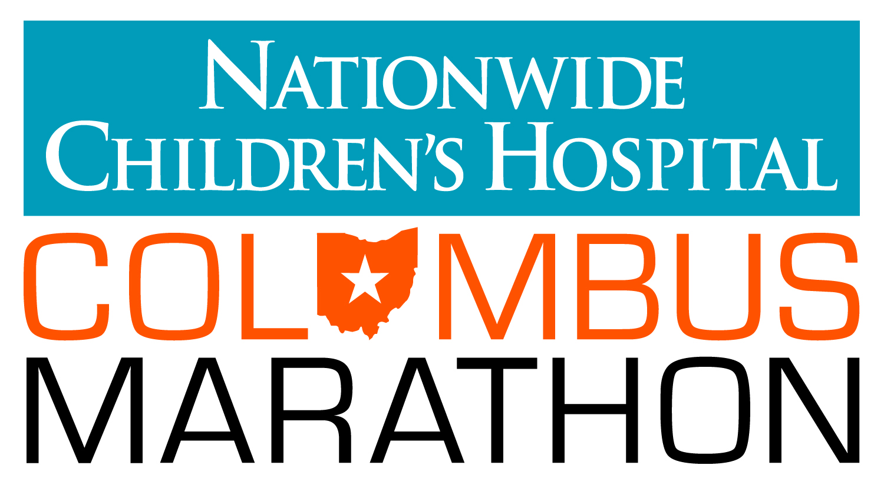

FOR IMMEDIATE RELEASE FOR MORE INFORMATION:
Oct. 14, 2015 Sarah Irvin Clark, Irvin PR, 614.296.4057 (cell)
Jane Carroll, Goodwill, 614.570.7948 (cell)

Goodwill Columbus ‘Cleans Up’ at Marathon

In a trend that is sweeping the nation’s marathons, clothes discarded by toasty runners are being picked up by Goodwill volunteers. Effort diverts thousands of tons of clothing from landfills, with the best of the best clothing resold at Goodwill stores. Proceeds go to support Goodwill programming to help people with disabilities and other barriers lead better, stronger and happier lives.

COLUMBUS - At the starting line and at about four miles in. That’s where Goodwill Columbus Retail Donations Manager Todd Cordetti says the layers will start to drop as the runners get hot on October 18 at the Nationwide Children’s Hospital Columbus Marathon & 1/2 Marathon.

“And that’s where our volunteers will be to pick them up,” said Cordetti. “It’s a perfect system. Runners love the fact that instead of their clothing ending up in a landfill, they are donating their clothes to support people in need, and we love getting an amazing variety of running clothes from around the United States and the world to sell to support our programs.”

Cordetti refers to these designated collection areas as “hot spots,” and has taken the extra step of setting up unmanned collection bins along the route so runners have additional donation options throughout the race.

Last year, more than 8,000 lbs. of clothing was collected at the marathon and diverted from landfills. 100 percent of it is sold and the proceeds support programming for people with disabilities and other barriers, including those with insecure housing situations, veterans, people returning to the workforce and unemployed and underemployed youth. Locally operated Goodwill organizations host similar marathon clothing pickups in New York City, Austin, Pittsburgh, Cincinnati and other cities. “It is turning into something really great for Goodwills across the nation,” said Cordetti.

In addition to the volunteer collection efforts in Columbus, Goodwill Janitorial Services has been contracted by the marathon to assist volunteers with race cleanup.
During the two days preceding the marathon, October 16 and 17, runners will gather at the Nationwide Children's Hospital Columbus Marathon Health & Fitness Expo where more than 100 vendors’ wares will be on display. This year will be the fourth year Goodwill Columbus will have a boutique at the expo, and will sell new (tags still on) and gently used jackets, running shorts, sports bras, t-shirts and pants prior to the race. All garments will be $5.00—including tax—regardless of retail value, which for many of the new garments exceeds $60. The boutique will also sell hats and gloves for $2.00 and pedometers for $1.00.
But it’s not all about buying and donating clothing.
Cordetti recalled a woman last year who made a mad dash for the women’s jackets in the Goodwill boutique at the expo. “She grabbed a bright yellow jacket and had this look of complete awe,” he said. “Out of curiosity, I asked her why she had such a strong reaction to that jacket and she let me know it was the very same jacket she bought at the expo the year prior and discarded when she got hot, and she could not believe her luck to find it again in 2014. I didn’t see it come through this year, so I am going to guess she did not let it go a second time.”
The Nationwide Children's Hospital Columbus Marathon & 1/2 Marathon is the 17th largest U.S. marathon. It has been ranked by Runner's World as one of the top 20 marathons in the United States and by USA Today as one of the top 10 fall marathons. In the past three years, between participants’ fundraising efforts, corporate and community sponsorships and matches by the Marathon board, more than $3 million has been raised for Nationwide Children’s. For more information, visit www.columbusmarathon.com.

Goodwill Columbus has been proudly serving the local community for 75 years. Since 1939 the agency has dedicated itself to building independence, quality of life and work opportunities for individuals with disabilities and other barriers. Goodwill Columbus is the sixth largest nonprofit in central Ohio and is among the top 50 largest employers central Ohio. Last year, Goodwill Columbus provided more than 1.3 million hours of service to more than 3,200 participants with disabilities and other barriers through day habilitation programs, community-based supported living services, employment training and job placement services. For more information on Goodwill Columbus, please visit www.goodwillcolumbus.org
###

